**Diagnostic Lab Website using python CGI**

**A PROJECT REPORT**

***Submitted by***

**SAYAK CHATTERJEE ( 430118010055 )**

**SOURIN KUMAR PAUL (430118010025)**

**Of**

**NARULA INSTITUTE OF TECHNOLOGY**



***at***

**ARDENT Computech Pvt. Ltd.**



**BONAFIDE CERTIFICATE**

Certified that this project report on **‘Diagnostic Lab Website’** in python is the bonafide work of **Sayak Chatterjee** and **Sourin Kumar Paul** who carried out the project work under my supervision.

**Signature of H.O.D. Signature of Mentor**

**___________________ ______________________**

**Prof. Jayanta Paul Prof. Meghali Das**

**Narula Institute of Technology, Ardent Computech Pvt. Ltd.**

**Agarpara, Kolkata Salt Lake, Kolkata**

**ACKNOWLEDGEMENT**

The project ***“Diagnostic Lab Website using python CGI”*** would not have been possible without the constant guidance of our guide  **Prof. Meghali Das**, Ardent Computech Pvt. Ltd. ,who guided us throughout this process despite her busy schedule. We are immensely thankful to her for her valuable ideas on improvement of the project.

We are also grateful to **Prof**. **Jayanta Paul**, our HOD, for all the help he provided. The brainstorming sessions that we had during the project development process, led to serious arguments and disagreements, but only for the betterment of the project.

**SAYAK CHATTERJEE ( 430118010055 )**

**SOURIN KUMAR PAUL (430118010025)**

BTECH,

Narula Institute of Technology,

4th semester, 2nd year.

**CONTENTS**

**SL. TOPICS PAGE No.**

1. Introduction5
2. Scope of the project 5
3. Implementation 5
4. Basic concepts and tools 6-7
5. E-R Diagram 8
6. Data Flow Diagram 9
7. Test results 10-12
8. Code snippets 13-45

* index.html 13-32
* testpackage.py 32-34
* login.py 34-49
* admin_report_update.py 39-40
* viewreport.py 40-43
* logout.html 44
* test_plot.py 44-45

1. Conclusion 46
2. Bibliography 46

**Introduction**

Diagnostic Labs are a need of modern day as many people require to conduct periodic test, more and more people are opting for regular checkups to asses their health situation. People are visiting these centers more often and having a website would be a great opportunity for increasing their business. Through the website a diagnostic lab can reach to a larger number people . A website will also be helpful for the customers.

This site will help the customers to book blood test online so they can avoid rush and standing in long queues for having an appointment. The reports can be published online so that customers can have a look at their report from the comfort of their home .

**Scope of the project**

This project can be further improved with more features in the near future.

**Implementation**

We have implemented our website in localhost using xampp server. A sample name of BloodFair is assigned for a better understanding of our model.

**BASIC CONCEPTS AND TOOLS**

### *Introduction to Python*

Python  is a widely used general-purpose, high level programming language. It was initially designed by Guido van Rossum in 1991 and developed by Python Software Foundation. It was mainly developed for emphasis on code readability, and its syntax allows programmers to express concepts in fewer lines of code.

Python is a programming language that lets you work quickly and integrate systems more efficiently.

There are two major Python versions- **Python 2 and Python 3**. Both are quite different.

Python interpreters are available for many operating systems. CPython, the reference implementation of Python, is open source software and has a community-based development model, as do nearly all of Python's other implementations. Python and CPython are managed by the non-profit python software foundation.

***Characteristics of Python***

### Open Source

Like PHP, Rust, Swift and Perl, Python is an open-source software, meaning its source code is available within the license, and users are allowed to access, modify and/or distribute to the code to anyone without the developer’s permission.

### Portable

Because it’s an open-source software, Python has been ported to run on a variety of different platforms, some of which include Windows, Mac, Solaris, OS/2, BeOS, PlayStation, Sharp Zarus, Windows CE, PocketPC and more. But if you intend to run Python on a different platform, use caution to ensure that no system-dependent features are being used.

### Object-Oriented and Procedure-Oriented

Python supports both procedure-oriented and object-oriented functions. Procedure-oriented means the language is designed around procedures and functions that are reused throughout the language. In comparison, object-oriented means the language is built around objects that combine data and functionality.

### Embeddable

Python is embeddable with C or C++ programming, allowing users to enhance their code with scripting functions.

### Easy to Learn

Python is a beginner-friendly programming language that’s easy to learn, regardless of your experience/knowledge with the language. If you’re a newcomer who’s looking to learn his or her first language, give Python a try. Its simplistic syntax makes learning fun and easy, which is a rare trait among most programming languages.

### Libraries

One of Python’s greatest strengths is its libraries. The standard library contains tools to assist programmers in using the language, supporting many formats and protocols like MIME and HTTP. Also included in Python’s standard library is modules for creating graphical user interfaces, modules for manipulating regular expressions, and modules for unit testing. It’s important to note, however, that the standard library is not required to run or use Python in an application.

**Tools**

**Xampp**

**XAMPP** is a free and open source cross platform web server solution stack package developed by Apache Friends, consisting mainly of the Apache HTTP server, MariaDB database, and interprets for scripts written in the PHP, Python and Perl programming language. Since most actual web server deployments use the same components as XAMPP, it makes transitioning from a local test server to a live server possible.

**E-R DIAGRAM**

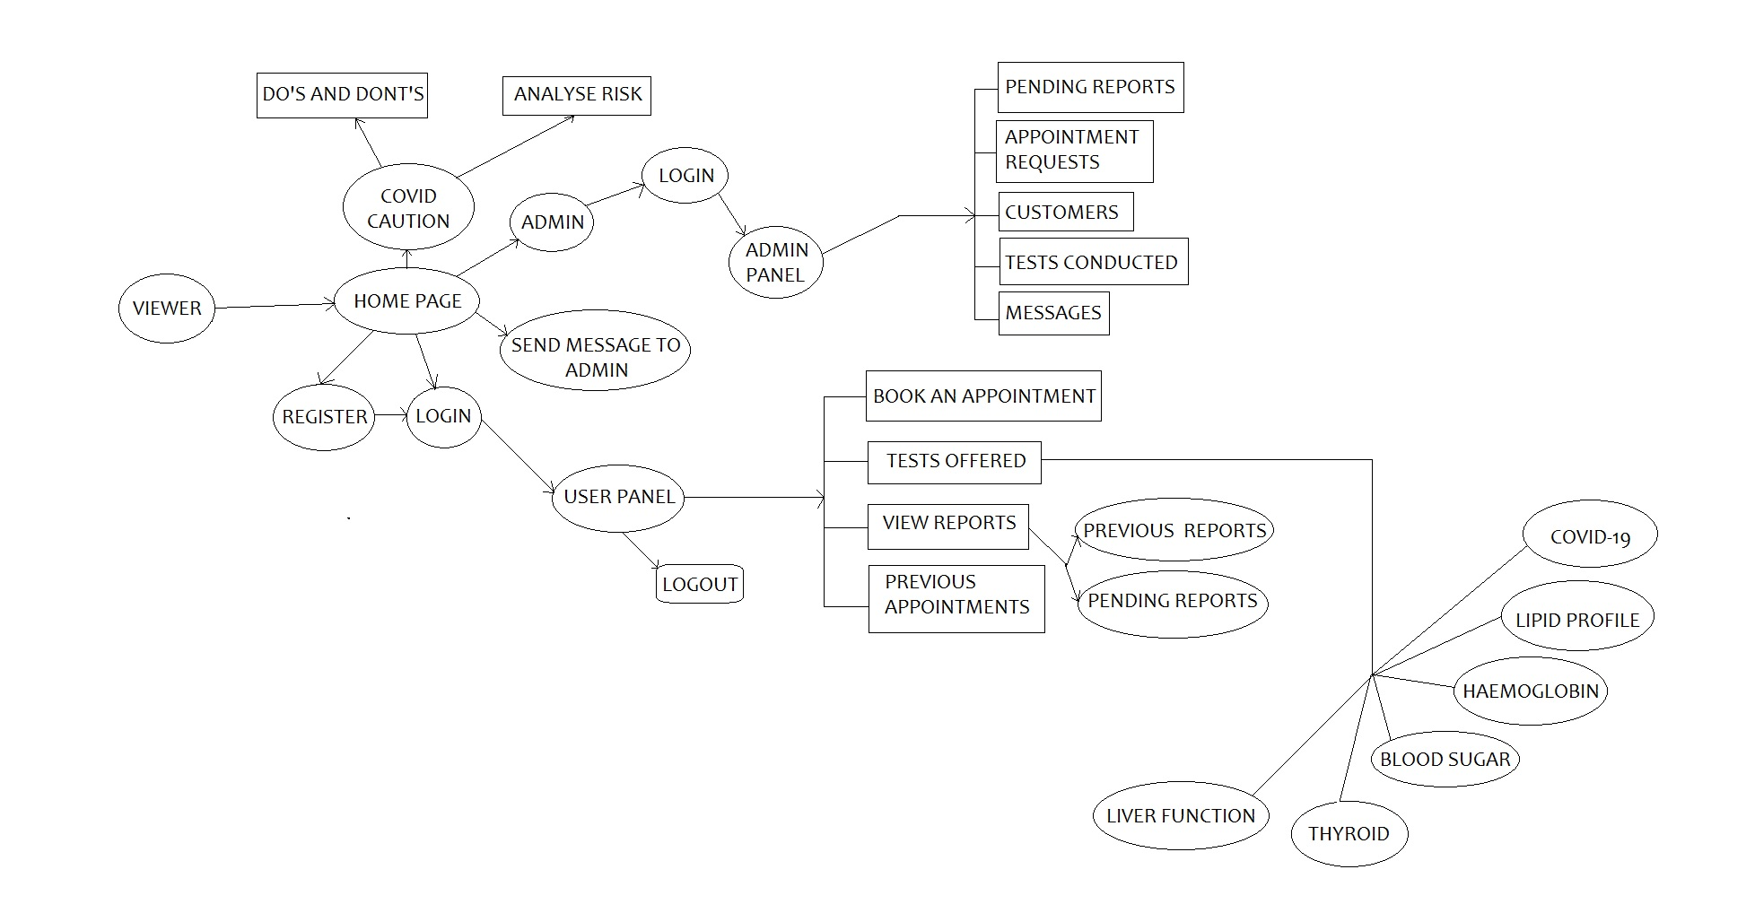

**Data Flow Diagram**

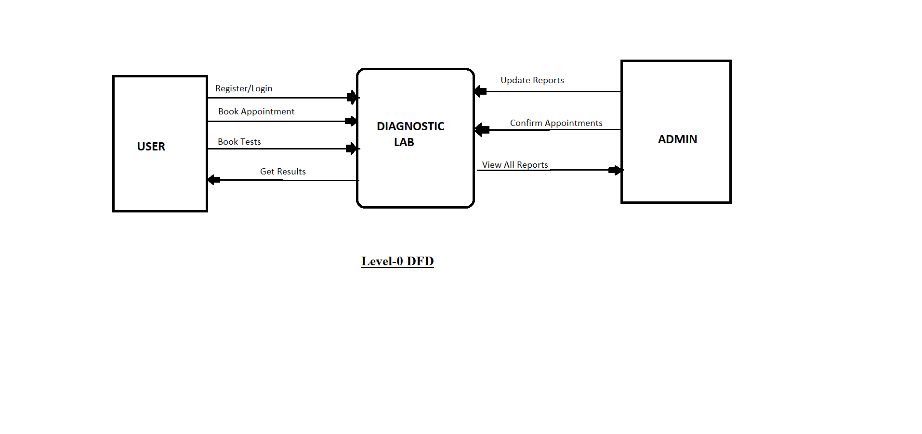

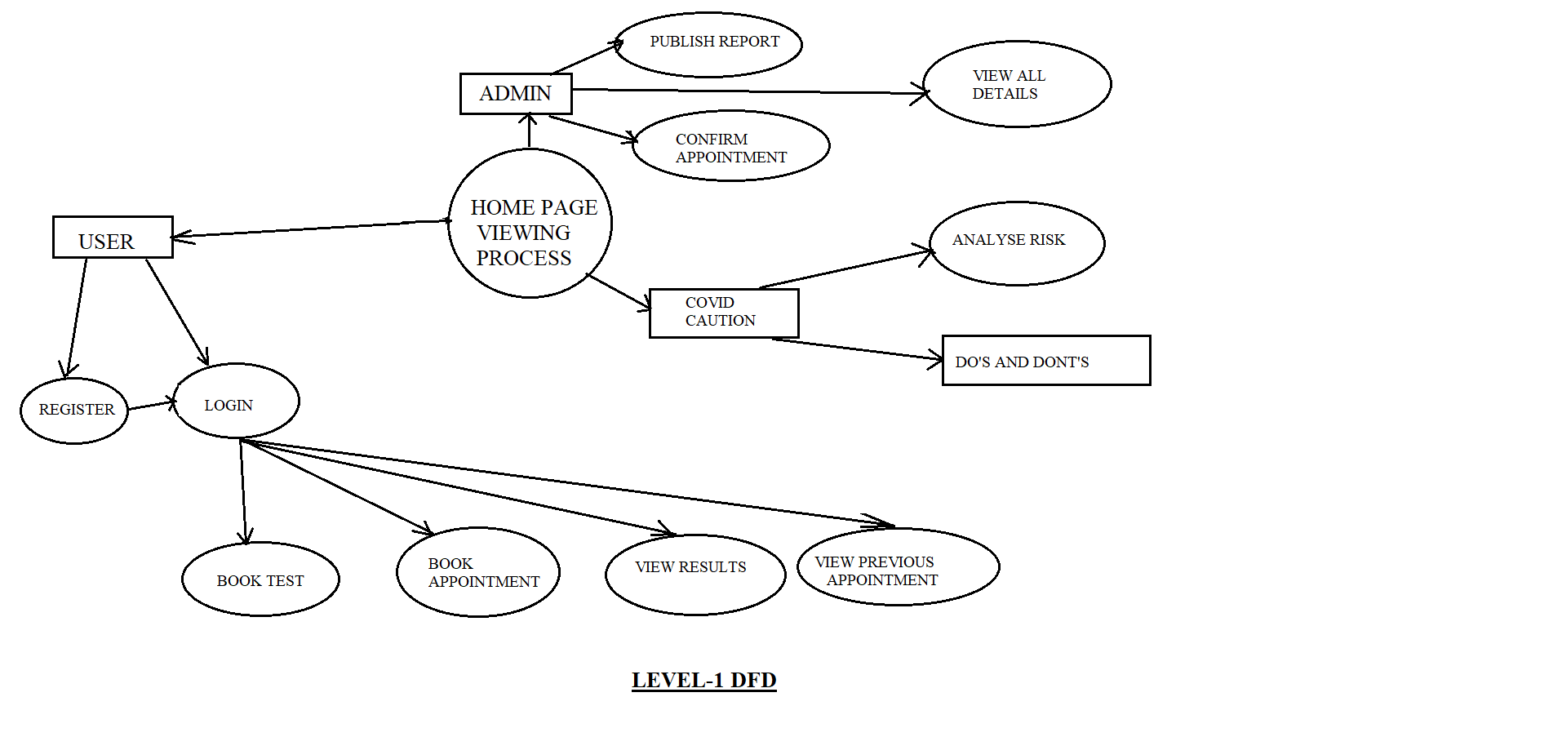

**TEST RESULTS**

**Home page :**

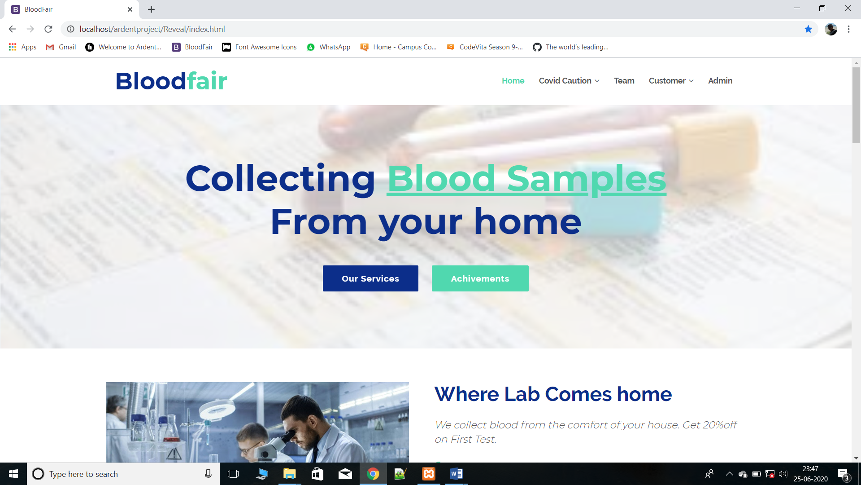

**Admin Login:**

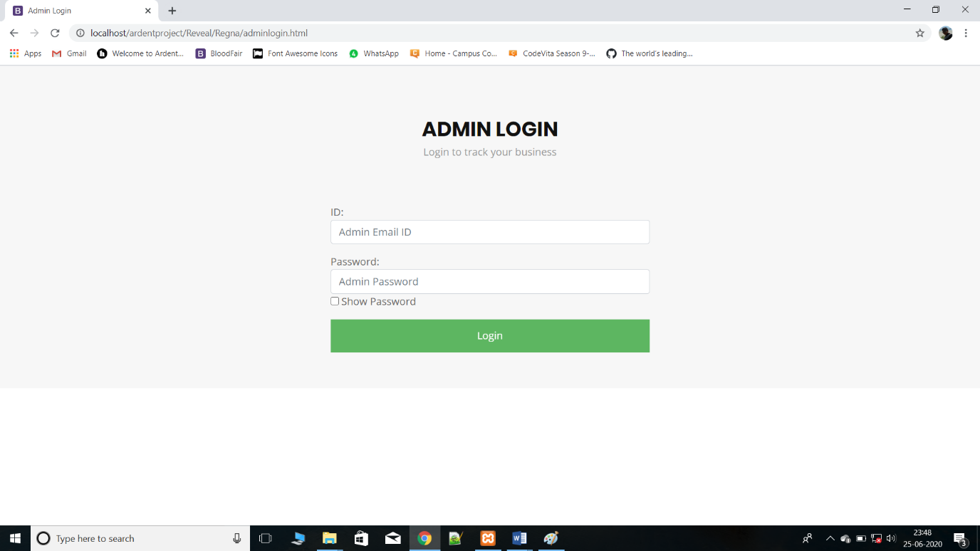

**Admin panel:**

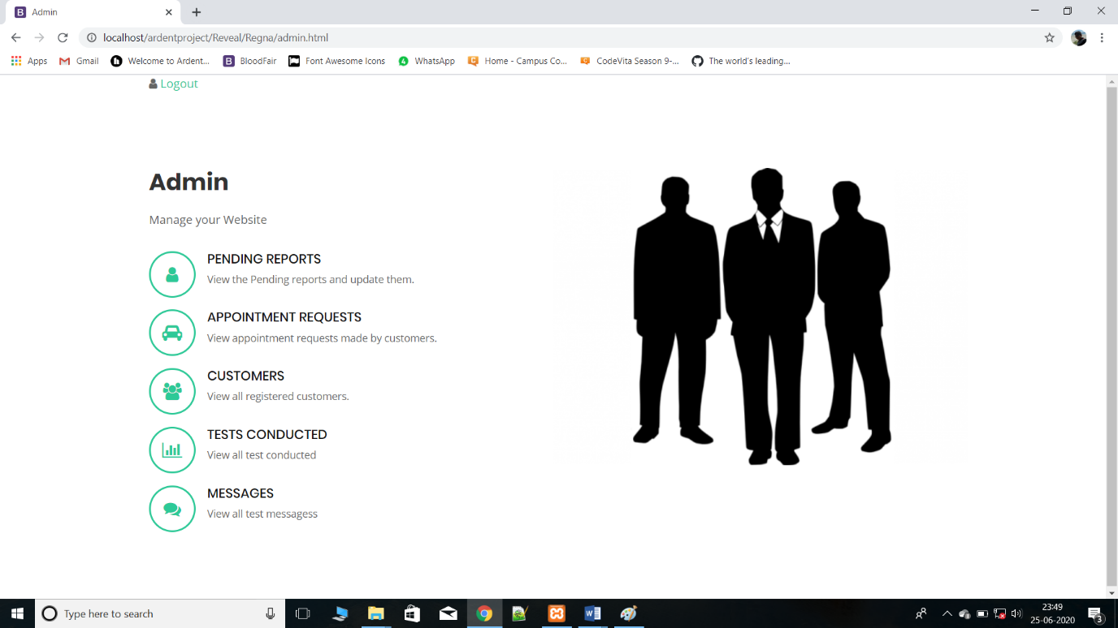

**User Login:**

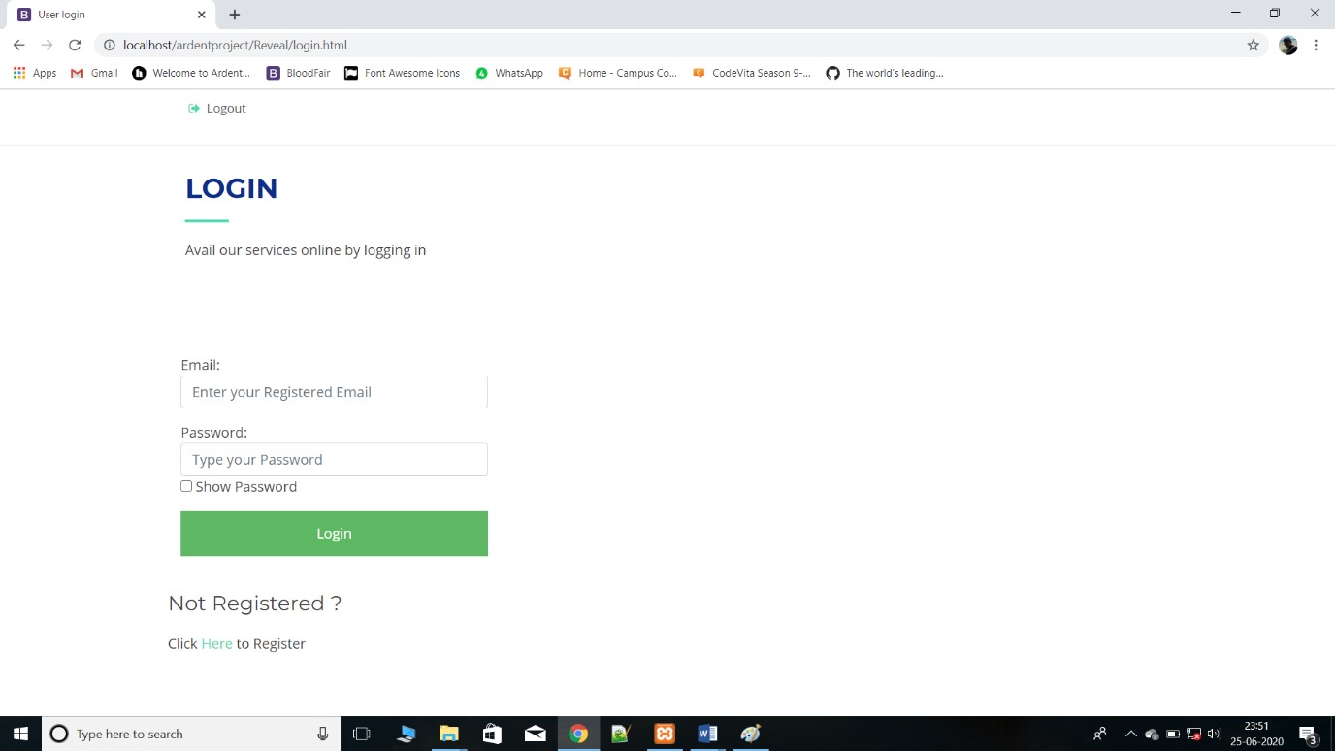

**User Panel:**

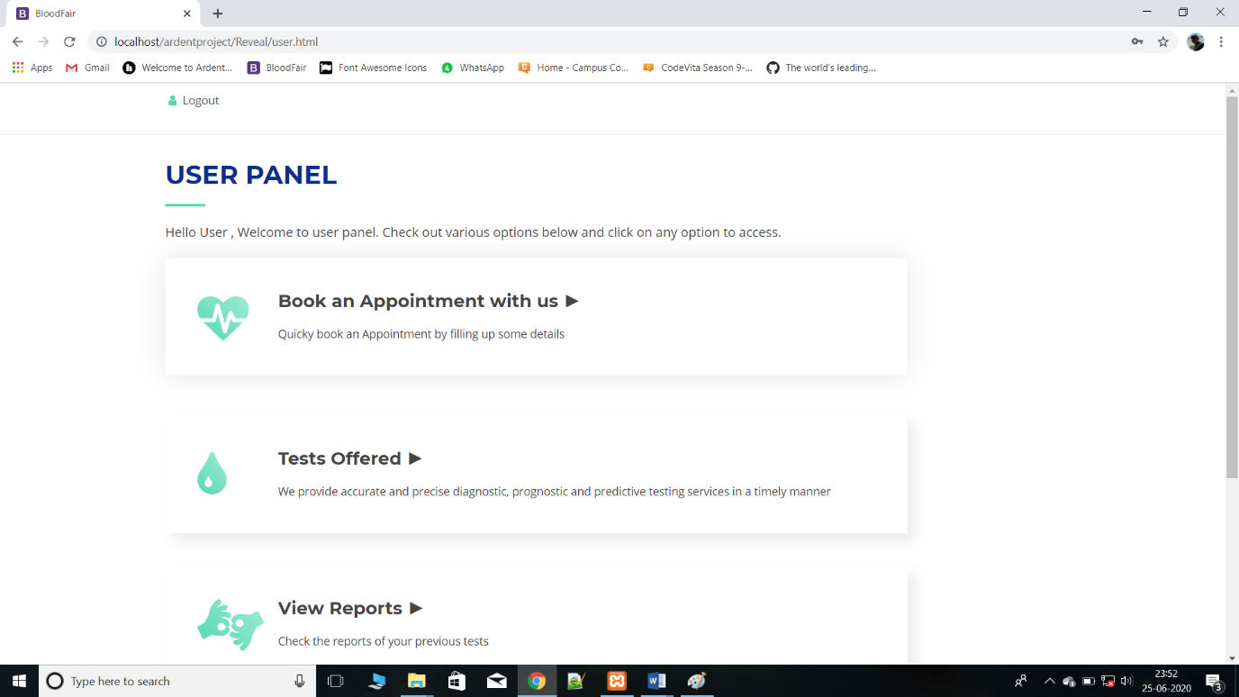

**Report Download:**

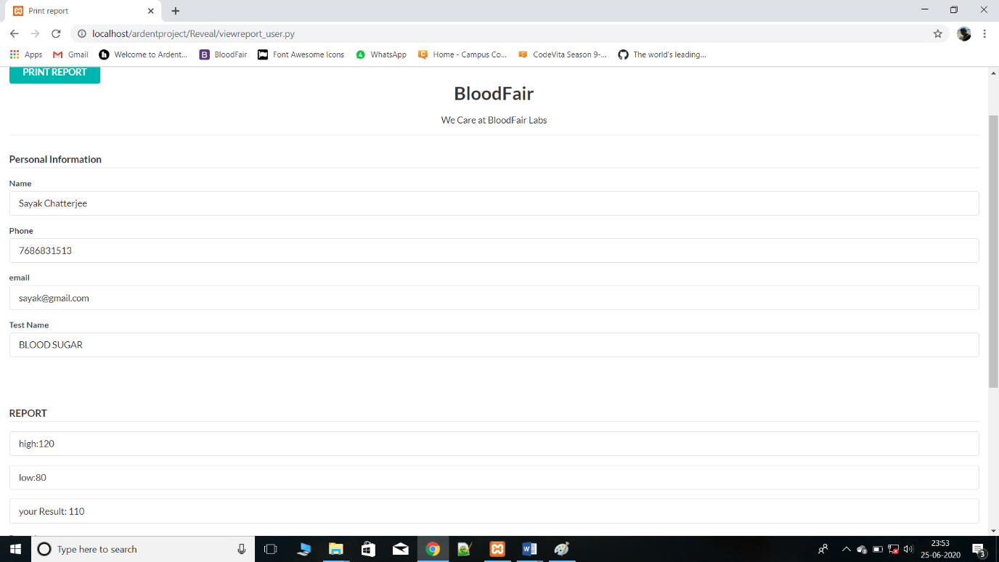

**Code snippets from the implementation**

**index.html**

<!DOCTYPE html>

<html lang="en">

<head>

<meta charset="utf-8">

<title>BloodFair</title>

<meta content="width=device-width, initial-scale=1.0" name="viewport">

<meta content="" name="keywords">

<meta content="" name="description">

<!-- Favicons -->

<link href="img/favicon.png" rel="icon">

<link href="img/apple-touch-icon.png" rel="apple-touch-icon">

<!-- Google Fonts -->

<link href="https://fonts.googleapis.com/css?family=Open+Sans:300,300i,400,400i,700,700i|Raleway:300,400,500,700,800|Montserrat:300,400,700" rel="stylesheet">

<!-- Bootstrap CSS File -->

<link href="lib/bootstrap/css/bootstrap.min.css" rel="stylesheet">

<!-- Libraries CSS Files -->

<link href="lib/font-awesome/css/font-awesome.min.css" rel="stylesheet">

<link href="lib/animate/animate.min.css" rel="stylesheet">

<link href="lib/ionicons/css/ionicons.min.css" rel="stylesheet">

<link href="lib/owlcarousel/assets/owl.carousel.min.css" rel="stylesheet">

<link href="lib/magnific-popup/magnific-popup.css" rel="stylesheet">

<link href="lib/ionicons/css/ionicons.min.css" rel="stylesheet">

<!-- Main Stylesheet File -->

<link href="css/style.css" rel="stylesheet">

<!-- =======================================================

Theme Name: Reveal

Theme URL: https://bootstrapmade.com/reveal-bootstrap-corporate-template/

Author: BootstrapMade.com

License: https://bootstrapmade.com/license/

======================================================= -->

</head>

<body id="body">

<!--==========================

Top Bar

============================-->

<section id="topbar" class="d-none d-lg-block">

<div class="container clearfix">

<div class="contact-info float-left">

<i class="fa fa-envelope-o"></i> <a href="mailto:contact@example.com">contactbloodfair@gmail.com</a>

<i class="fa fa-phone"></i> +91 ***** *****

</div>

<div class="social-links float-right">

<a href="#" class="twitter"><i class="fa fa-twitter"></i></a>

<a href="#" class="facebook"><i class="fa fa-facebook"></i></a>

<a href="#" class="instagram"><i class="fa fa-instagram"></i></a>

<a href="#" class="google-plus"><i class="fa fa-google-plus"></i></a>

<a href="#" class="linkedin"><i class="fa fa-linkedin"></i></a>

</div>

</div>

</section>

<!--==========================

Header

============================-->

<header id="header">

<div class="container">

<div id="logo" class="pull-left">

<h1><a href="#body" class="scrollto">Blood<span>fair</span></a></h1>

<!-- Uncomment below if you prefer to use an image logo -->

<!-- <a href="#body"><img src="img/logo.png" alt="" title="" /></a>-->

</div>

<nav id="nav-menu-container">

<ul class="nav-menu">

<li class="menu-active"><a href="#body">Home</a></li>

<li><a href="#about">Covid Caution</a></li>

<li><a href="#services">Tests Offered</a></li>

<li><a href="#portfolio">Appointment</a></li>

<li><a href="#team">Team</a></li>

<li class="menu-has-children"><a href="">Options</a>

<ul>

<li><a href="#">Register</a></li>

<li><a href="#">Login</a></li>

<li><a href="#">View Report</a></li>

<li><a href="#">drop down 4</a></li>

</ul>

</li>

<li><a href="#contact">Contact</a></li>

</ul>

</nav><!-- #nav-menu-container -->

</div>

</header><!-- #header -->

<!--==========================

Intro Section

============================-->

<section id="intro">

<div class="intro-content">

<h2>Collecting <span>Blood Samples</span><br>From your home</h2>

<div>

<a href="#about" class="btn-get-started scrollto">Our Services</a>

<a href="#portfolio" class="btn-projects scrollto">Achivements</a>

</div>

</div>

<div id="intro-carousel" class="owl-carousel" >

<div class="item" style="background-image: url('img/intro-carousel/1.jpg');"></div>

<div class="item" style="background-image: url('img/intro-carousel/2.jpg');"></div>

<div class="item" style="background-image: url('img/intro-carousel/3.jpg');"></div>

<div class="item" style="background-image: url('img/intro-carousel/4.jpg');"></div>

<div class="item" style="background-image: url('img/intro-carousel/5.jpg');"></div>

</div>

</section><!-- #intro -->

<main id="main">

<!--==========================

About Section

============================-->

<section id="about" class="wow fadeInUp">

<div class="container">

<div class="row">

<div class="col-lg-6 about-img">

<img src="img/about-img.jpg" alt="">

</div>

<div class="col-lg-6 content">

<h2>Where Lab Comes home</h2>

<h3>We collect blood from the comfort of your house. Get 20%off on First Test.</h3>

<ul>

<li><i class="ion-android-checkmark-circle"></i> Expert Doctors</li>

<li><i class="ion-android-checkmark-circle"></i> High quality testing Faculty.</li>

<li><i class="ion-android-checkmark-circle"></i> Report Within 24 Hours</li>

</ul>

</div>

</div>

</div>

</section><!-- #about -->

<!--==========================

TESTS OFFERED

============================-->

<section id="services">

<div class="container">

<div class="section-header">

<h2>TESTS OFFERED</h2>

<p> We offer all kind of tests. Guranteed 24 hours reporting. High quality testing. Trained proffessionals.</p>

</div>

<div class="row">

<div class="col-lg-6">

<div class="box wow fadeInLeft">

<div class="icon"><i class="fa fa-bar-chart"></i></div>

<h4 class="title"><a href="">COVID-19 </a></h4>

<p class="description">covid-19 Test Available now. RTPCR & RAPID ANTIBODY TESTING</p>

</div>

</div>

<div class="col-lg-6">

<div class="box wow fadeInRight">

<div class="icon"><i class="fa fa-picture-o"></i></div>

<h4 class="title"><a href="">Lipid Profile</a></h4>

<p class="description">Complete And Partial Packages</p>

</div>

</div>

<div class="col-lg-6">

<div class="box wow fadeInLeft" data-wow-delay="0.2s">

<div class="icon"><i class="fa fa-shopping-bag"></i></div>

<h4 class="title"><a href="">Blood Sugar</a></h4>

<p class="description">Fasting & PP</p>

</div>

</div>

<div class="col-lg-6">

<div class="box wow fadeInRight" data-wow-delay="0.2s">

<div class="icon"><i class="fa fa-map"></i></div>

<h4 class="title"><a href="">Thyroid</a></h4>

<p class="description">Tsh/T4/T3</p>

</div>

</div>

</div>

</div>

</section><!-- #services -->

<!--==========================

PARTNERS

============================-->

<section id="clients" class="wow fadeInUp">

<div class="container">

<div class="section-header">

<h2>PARTNERS</h2>

<p>Our lab collaborates with the finest labs in India and abord</p>

</div>

<div class="owl-carousel clients-carousel">

<img src="img/clients/client-1.png" alt="">

<img src="img/clients/client-2.png" alt="">

<img src="img/clients/client-3.png" alt="">

<img src="img/clients/client-4.png" alt="">

<img src="img/clients/client-5.png" alt="">

<img src="img/clients/client-6.png" alt="">

<img src="img/clients/client-7.png" alt="">

<img src="img/clients/client-8.png" alt="">

</div>

</div>

</section><!-- #clients -->

<!--==========================

Our ACHIVEMENTS

============================-->

<section id="portfolio" class="wow fadeInUp">

<div class="container">

<div class="section-header">

<h2>Our Achivements</h2>

<p>From each test we conduct 5% is donated from it to the less privilaged. Blood donation camps are organsed frequently by us.</p>

</div>

</div>

<div class="container-fluid">

<div class="row no-gutters">

<div class="col-lg-3 col-md-4">

<div class="portfolio-item wow fadeInUp">

<a href="img/portfolio/1.jpg" class="portfolio-popup">

<img src="img/portfolio/1.jpg" alt="">

<div class="portfolio-overlay">

<div class="portfolio-info"><h2 class="wow fadeInUp">Portfolio Item 1</h2></div>

</div>

</a>

</div>

</div>

<div class="col-lg-3 col-md-4">

<div class="portfolio-item wow fadeInUp">

<a href="img/portfolio/2.jpg" class="portfolio-popup">

<img src="img/portfolio/2.jpg" alt="">

<div class="portfolio-overlay">

<div class="portfolio-info"><h2 class="wow fadeInUp">Portfolio Item 2</h2></div>

</div>

</a>

</div>

</div>

<div class="col-lg-3 col-md-4">

<div class="portfolio-item wow fadeInUp">

<a href="img/portfolio/3.jpg" class="portfolio-popup">

<img src="img/portfolio/3.jpg" alt="">

<div class="portfolio-overlay">

<div class="portfolio-info"><h2 class="wow fadeInUp">Portfolio Item 3</h2></div>

</div>

</a>

</div>

</div>

<div class="col-lg-3 col-md-4">

<div class="portfolio-item wow fadeInUp">

<a href="img/portfolio/4.jpg" class="portfolio-popup">

<img src="img/portfolio/4.jpg" alt="">

<div class="portfolio-overlay">

<div class="portfolio-info"><h2 class="wow fadeInUp">Portfolio Item 4</h2></div>

</div>

</a>

</div>

</div>

<div class="col-lg-3 col-md-4">

<div class="portfolio-item wow fadeInUp">

<a href="img/portfolio/5.jpg" class="portfolio-popup">

<img src="img/portfolio/5.jpg" alt="">

<div class="portfolio-overlay">

<div class="portfolio-info"><h2 class="wow fadeInUp">Portfolio Item 5</h2></div>

</div>

</a>

</div>

</div>

<div class="col-lg-3 col-md-4">

<div class="portfolio-item wow fadeInUp">

<a href="img/portfolio/6.jpg" class="portfolio-popup">

<img src="img/portfolio/6.jpg" alt="">

<div class="portfolio-overlay">

<div class="portfolio-info"><h2 class="wow fadeInUp">Portfolio Item 6</h2></div>

</div>

</a>

</div>

</div>

<div class="col-lg-3 col-md-4">

<div class="portfolio-item wow fadeInUp">

<a href="img/portfolio/7.jpg" class="portfolio-popup">

<img src="img/portfolio/7.jpg" alt="">

<div class="portfolio-overlay">

<div class="portfolio-info"><h2 class="wow fadeInUp">Portfolio Item 7</h2></div>

</div>

</a>

</div>

</div>

<div class="col-lg-3 col-md-4">

<div class="portfolio-item wow fadeInUp">

<a href="img/portfolio/8.jpg" class="portfolio-popup">

<img src="img/portfolio/8.jpg" alt="">

<div class="portfolio-overlay">

<div class="portfolio-info"><h2 class="wow fadeInUp">Portfolio Item 8</h2></div>

</div>

</a>

</div>

</div>

</div>

</div>

</section><!-- #portfolio -->

<!--==========================

WHAT OUR PATIENTS SAYAS

============================-->

<section id="testimonials" class="wow fadeInUp">

<div class="container">

<div class="section-header">

<h2>What Our Patients says???</h2>

<p>Our objective is to provide good quality testing at a resonable price. Lets hear from our patients.... </p>

</div>

<div class="owl-carousel testimonials-carousel">

<div class="testimonial-item">

<p>

<img src="img/quote-sign-left.png" class="quote-sign-left" alt="">

Proin iaculis purus consequat sem cure digni ssim donec porttitora entum suscipit rhoncus. Accusantium quam, ultricies eget id, aliquam eget nibh et. Maecen aliquam, risus at semper.

<img src="img/quote-sign-right.png" class="quote-sign-right" alt="">

</p>

<img src="img/testimonial-1.jpg" class="testimonial-img" alt="">

<h3>Saul Goodman</h3>

<h4>Ceo &amp; Founder</h4>

</div>

<div class="testimonial-item">

<p>

<img src="img/quote-sign-left.png" class="quote-sign-left" alt="">

Export tempor illum tamen malis malis eram quae irure esse labore quem cillum quid cillum eram malis quorum velit fore eram velit sunt aliqua noster fugiat irure amet legam anim culpa.

<img src="img/quote-sign-right.png" class="quote-sign-right" alt="">

</p>

<img src="img/testimonial-2.jpg" class="testimonial-img" alt="">

<h3>Sara Wilsson</h3>

<h4>Designer</h4>

</div>

<div class="testimonial-item">

<p>

<img src="img/quote-sign-left.png" class="quote-sign-left" alt="">

Enim nisi quem export duis labore cillum quae magna enim sint quorum nulla quem veniam duis minim tempor labore quem eram duis noster aute amet eram fore quis sint minim.

<img src="img/quote-sign-right.png" class="quote-sign-right" alt="">

</p>

<img src="img/testimonial-3.jpg" class="testimonial-img" alt="">

<h3>Jena Karlis</h3>

<h4>Store Owner</h4>

</div>

<div class="testimonial-item">

<p>

<img src="img/quote-sign-left.png" class="quote-sign-left" alt="">

Fugiat enim eram quae cillum dolore dolor amet nulla culpa multos export minim fugiat minim velit minim dolor enim duis veniam ipsum anim magna sunt elit fore quem dolore labore illum veniam.

<img src="img/quote-sign-right.png" class="quote-sign-right" alt="">

</p>

<img src="img/testimonial-4.jpg" class="testimonial-img" alt="">

<h3>Matt Brandon</h3>

<h4>Freelancer</h4>

</div>

<div class="testimonial-item">

<p>

<img src="img/quote-sign-left.png" class="quote-sign-left" alt="">

Quis quorum aliqua sint quem legam fore sunt eram irure aliqua veniam tempor noster veniam enim culpa labore duis sunt culpa nulla illum cillum fugiat legam esse veniam culpa fore nisi cillum quid.

<img src="img/quote-sign-right.png" class="quote-sign-right" alt="">

</p>

<img src="img/testimonial-5.jpg" class="testimonial-img" alt="">

<h3>John Larson</h3>

<h4>Entrepreneur</h4>

</div>

</div>

</div>

</section><!-- #testimonials -->

<!--==========================

BOOK A TEST NOW

============================-->

<section id="call-to-action" class="wow fadeInUp">

<div class="container">

<div class="row">

<div class="col-lg-9 text-center text-lg-left">

<h3 class="cta-title">Book A Test Now</h3>

<p class="cta-text">Book now and we will reach you at your home. Enjot 20% flat off on first test. Hurray for an appiontment!!!! </p>

</div>

<div class="col-lg-3 cta-btn-container text-center">

<a class="cta-btn align-middle" href="#">Appiontment</a>

</div>

</div>

</div>

</section><!-- #call-to-action -->

<!--==========================

Our Team Section

============================-->

<section id="team" class="wow fadeInUp">

<div class="container">

<div class="section-header">

<h2>Our Team</h2>

</div>

<div class="row">

<div class="col-lg-3 col-md-6">

<div class="member">

<div class="pic"><img src="img/team-1.jpg" alt=""></div>

<div class="details">

<h4>Sayak Chatterjee</h4>

<span> Developer</span>

<div class="social">

<a href=""><i class="fa fa-twitter"></i></a>

<a href=""><i class="fa fa-facebook"></i></a>

<a href=""><i class="fa fa-google-plus"></i></a>

<a href=""><i class="fa fa-linkedin"></i></a>

</div>

</div>

</div>

</div>

<div class="col-lg-3 col-md-6">

<div class="member">

<div class="pic"><img src="img/team-2.jpg" alt=""></div>

<div class="details">

<h4>Sourin Kumar Paul</h4>

<span>Developer</span>

<div class="social">

<a href=""><i class="fa fa-twitter"></i></a>

<a href=""><i class="fa fa-facebook"></i></a>

<a href=""><i class="fa fa-google-plus"></i></a>

<a href=""><i class="fa fa-linkedin"></i></a>

</div>

</div>

</div>

</div>

<div class="col-lg-3 col-md-6">

<div class="member">

<div class="pic"><img src="img/team-3.jpg" alt=""></div>

<div class="details">

<h4>William Anderson</h4>

<span>CTO</span>

<div class="social">

<a href=""><i class="fa fa-twitter"></i></a>

<a href=""><i class="fa fa-facebook"></i></a>

<a href=""><i class="fa fa-google-plus"></i></a>

<a href=""><i class="fa fa-linkedin"></i></a>

</div>

</div>

</div>

</div>

<div class="col-lg-3 col-md-6">

<div class="member">

<div class="pic"><img src="img/team-4.jpg" alt=""></div>

<div class="details">

<h4>Amanda Jepson</h4>

<span>Accountant</span>

<div class="social">

<a href=""><i class="fa fa-twitter"></i></a>

<a href=""><i class="fa fa-facebook"></i></a>

<a href=""><i class="fa fa-google-plus"></i></a>

<a href=""><i class="fa fa-linkedin"></i></a>

</div>

</div>

</div>

</div>

</div>

</div>

</section><!-- #team -->

<!--==========================

Contact Section

============================-->

<section id="contact" class="wow fadeInUp">

<div class="container">

<div class="section-header">

<h2>Contact Us</h2>

<p>contact us at given below address. We provide expert solutions to all your health problems. FREE of cost!!</p>

</div>

<div class="row contact-info">

<div class="col-md-4">

<div class="contact-address">

<i class="ion-ios-location-outline"></i>

<h3>Address</h3>

<address>Agarpara, kolkata, 24 PGS(N)</address>

</div>

</div>

<div class="col-md-4">

<div class="contact-phone">

<i class="ion-ios-telephone-outline"></i>

<h3>Phone Number</h3>

<p><a href="tel:+155895548855">+91 ***** *****</a></p>

</div>

</div>

<div class="col-md-4">

<div class="contact-email">

<i class="ion-ios-email-outline"></i>

<h3>Email</h3>

<p><a href="mailto:info@example.com">contactbloodfair@gmail.com</a></p>

</div>

</div>

</div>

</div>

<div class="container mb-4">

<iframe src="https://www.google.com/maps/embed?pb=!1m18!1m12!1m3!1d22864.11283411948!2d-73.96468908098944!3d40.630720240038435!2m3!1f0!2f0!3f0!3m2!1i1024!2i768!4f13.1!3m3!1m2!1s0x89c24fa5d33f083b%3A0xc80b8f06e177fe62!2sNew+York%2C+NY%2C+USA!5e0!3m2!1sen!2sbg!4v1540447494452" width="100%" height="380" frameborder="0" style="border:0" allowfullscreen></iframe>

</div>

<div class="container">

<div class="form">

<div id="sendmessage">Your message has been sent. Thank you!</div>

<div id="errormessage"></div>

<form action="" method="post" role="form" class="contactForm">

<div class="form-row">

<div class="form-group col-md-6">

<input type="text" name="name" class="form-control" id="name" placeholder="Your Name" data-rule="minlen:4" data-msg="Please enter at least 4 chars" />

<div class="validation"></div>

</div>

<div class="form-group col-md-6">

<input type="email" class="form-control" name="email" id="email" placeholder="Your Email" data-rule="email" data-msg="Please enter a valid email" />

<div class="validation"></div>

</div>

</div>

<div class="form-group">

<input type="text" class="form-control" name="subject" id="subject" placeholder="Subject" data-rule="minlen:4" data-msg="Please enter at least 8 chars of subject" />

<div class="validation"></div>

</div>

<div class="form-group">

<textarea class="form-control" name="message" rows="5" data-rule="required" data-msg="Please write something for us" placeholder="Message"></textarea>

<div class="validation"></div>

</div>

<div class="text-center"><button type="submit">Send Message</button></div>

</form>

</div>

</div>

</section><!-- #contact -->

</main>

<!--==========================

Footer

============================-->

<footer id="footer">

<div class="container">

<div class="copyright">

&copy; Copyright <strong>Sayak&Sourin @2020</strong>. All Rights Reserved

</div>

<div class="credits">

<!--

All the links in the footer should remain intact.

You can delete the links only if you purchased the pro version.

Licensing information: https://bootstrapmade.com/license/

Purchase the pro version with working PHP/AJAX contact form: https://bootstrapmade.com/buy/?theme=Reveal

-->

Designed by <a href="https://bootstrapmade.com/">BootstrapMade</a>

</div>

</div>

</footer><!-- #footer -->

<a href="#" class="back-to-top"><i class="fa fa-chevron-up"></i></a>

<!-- JavaScript Libraries -->

<script src="lib/jquery/jquery.min.js"></script>

<script src="lib/jquery/jquery-migrate.min.js"></script>

<script src="lib/bootstrap/js/bootstrap.bundle.min.js"></script>

<script src="lib/easing/easing.min.js"></script>

<script src="lib/superfish/hoverIntent.js"></script>

<script src="lib/superfish/superfish.min.js"></script>

<script src="lib/wow/wow.min.js"></script>

<script src="lib/owlcarousel/owl.carousel.min.js"></script>

<script src="lib/magnific-popup/magnific-popup.min.js"></script>

<script src="lib/sticky/sticky.js"></script>

<!-- Contact Form JavaScript File -->

<script src="contactform/contactform.js"></script>

<!-- Template Main Javascript File -->

<script src="js/main.js"></script>

</body>

</html>

**testpackage.py**

#!C:\Users\sayak\Anaconda3\python.exe

print("Content-type:text/html\r\n\r\n")

import mysql.connector

import cgi

db=mysql.connector.connect(host="localhost",user="root",passwd="",db="ardent")

cur=db.cursor()

form=cgi.FieldStorage()

e=form['email'].value

t=form['package'].value

sl=''

s="p"

rep=""

r1=""

r2=""

r3=""

r4=""

cur.execute("insert into test values('{0}','{1}','{2}','{3}','{4}','{5}','{6}','{7}')".format(sl,e,t,s,r1,r2,r3,r4))

db.commit()

print("""

<html>

<head>

<style>

div {

margin: 0 auto;

width:1000px;

}

.alert {

padding: 30px;

background-color: #29CD3A;

color: white;

}

.closebtn {

margin-left: 15px;

color: white;

font-weight: bold;

float: right;

font-size: 22px;

line-height: 20px;

cursor: pointer;

transition: 0.3s;

}

.closebtn:hover {

color: black;

}

h2 {

font-size: 25px;

}

h4 {

font-size: 21px;

}

p {

font-size: 25px;

}

</style>

<meta http-equiv = "refresh" content="4; URL=http://localhost/ardentproject/Reveal/user.html" />

</head>

<body>

<br><h2 align="center">CONGRATULATIONS</h2>

<h4 align="center">Redirecting to User Panel within 4 seconds...<h4>

<div class="alert">

<span class="closebtn" onclick="this.parentElement.style.display='none';">&times;</span>

<p align="center"><strong>TEST Booked Successfully!</strong></p>

</div>

</body>

</html>""")

**login.py**

#!C:\Users\sayak\Anaconda3\python.exe

print("Content-type:text/html\r\n\r\n")

import mysql.connector

import cgi

db=mysql.connector.connect(host="localhost",user="root",passwd="",db="ardent")

cur=db.cursor()

form=cgi.FieldStorage()

e=form['email'].value

p=form['password'].value

cur.execute("SELECT email FROM register ")

x=cur.fetchall()

c=0

for i in x:

if i[0]==e:

c=1

break

if c==1:

cur.execute("select password from register where email='{0}'".format(e))

password=cur.fetchone()

db.commit()

if password[0]==p:

print("""

<html>

<head>

<script>document.cookie = "emailg = {0};";</script>

<meta http-equiv = "refresh" content="0; URL=http://localhost/ardentproject/Reveal/user.html" />

</head>

</html>""".format(e))

else :

print("""

<html>

<head>

<style>

div {

margin: 0 auto;

width:1000px;

}

.alert {

padding: 30px;

background-color: #f44336;

color: white;

}

.closebtn {

margin-left: 15px;

color: white;

font-weight: bold;

float: right;

font-size: 22px;

line-height: 20px;

cursor: pointer;

transition: 0.3s;

}

.closebtn:hover {

color: black;

}

h2 {

font-size: 25px;

}

h4 {

font-size: 21px;

}

p {

font-size: 25px;

}

</style>

<meta http-equiv = "refresh" content="4; URL=http://localhost/ardentproject/Reveal/login.html" />

</head>

<body>

<br><h2 align="center">Login Failed !</h2>

<h4 align="center">Redirecting to Login Page within 4 seconds...<h4>

<div class="alert">

<span class="closebtn" onclick="this.parentElement.style.display='none';">&times;</span>

<p align="center"><strong>Login Failed! Try Entering Correct Password</strong></p>

</div>

</body>

</html>""")

else:

db.commit()

print("""

<html>

<head>

<style>

div {

margin: 0 auto;

width:1000px;

}

.alert {

padding: 30px;

background-color: #f44336;

color: white;

}

.closebtn {

margin-left: 15px;

color: white;

font-weight: bold;

float: right;

font-size: 22px;

line-height: 20px;

cursor: pointer;

transition: 0.3s;

}

.closebtn:hover {

color: black;

}

h2 {

font-size: 25px;

}

h4 {

font-size: 21px;

}

p {

font-size: 25px;

}

</style>

<meta http-equiv = "refresh" content="4; URL=http://localhost/ardentproject/Reveal/register.html" />

</head>

<body>

<br><h2 align="center">NO USER FOUND !</h2>

<h4 align="center">Redirecting to Registration Page within 4 seconds...<h4>

<div class="alert">

<span class="closebtn" onclick="this.parentElement.style.display='none';">&times;</span>

<p align="center"><strong>YOU ARE NOT REGISTERED !</strong></p>

</div>

</body>

</html>""")

**admin_report_update.py**

#!C:\Users\sayak\Anaconda3\python.exe

print("Content-type:text/html\r\n\r\n")

import mysql.connector

import cgi

db=mysql.connector.connect(host="localhost",user="root",passwd="",db="ardent")

cur=db.cursor()

form=cgi.FieldStorage()

e=form['email'].value

t=form['test_name'].value

r1=form['r1'].value

r2=form['r2'].value

r3=form['r3'].value

r4=form['r4'].value

cur.execute("UPDATE test SET status = 'd',r1='{0}',r2='{1}',r3='{2}',r4='{3}' WHERE email='{4}' and test='{5}'".format(r1,r2,r3,r4,e,t) )

db.commit()

print('updated')

print("""

<html>

<head>

<meta http-equiv = "refresh" content="2; URL=http://localhost/ardentproject/Reveal/Regna/admin_report_fetch.py" />

</head>

</html>""")

**viewreport.py**

#!C:\Users\sayak\Anaconda3\python.exe

print("Content-type:text/html\r\n\r\n")

import mysql.connector

import cgi

db=mysql.connector.connect(host="localhost",user="root",passwd="",db="ardent")

cur=db.cursor()

form=cgi.FieldStorage()

i=int(form['index'].value)

i=i-1

cur.execute("SELECT register.name,register.phone,test.email,test.test FROM test INNER join register ON test.email=register.email where test.status='d'")

x=cur.fetchall()

email=x[i][2]

test=x[i][3]

cur.execute("SELECT register.name,register.phone,register.email,test.test,test.r1,test.r2,test.r3,test.r4 FROM test INNER join register ON test.email=register.email where test.status='d' and test.email='{0}' and test.test='{1}' ".format(email,test))

res=cur.fetchall()

db.commit()

print("""

<html lang="en">

<head>

<meta charset="UTF-8">

<title>Print report</title>

<link rel="stylesheet" type="text/css" href="//cdnjs.cloudflare.com/ajax/libs/semantic-ui/1.12.0/semantic.min.css">

</head>

<body>

<div class="ui page grid">

<div class="wide column">

<h1 class="ui header aligned center">BloodFair</h1>

<div class="ui divider hidden"></div>

</div>

</div>

<!-- scripts -->

<script src="//ajax.googleapis.com/ajax/libs/jquery/1.11.0/jquery.min.js"></script>

<script type="text/javascript" src="//cdn.rawgit.com/MrRio/jsPDF/master/dist/jspdf.min.js"></script>

<div class="ui segment">

<div class="ui button aligned center teal" id="create_pdf">PRINT REPORT</div>

<form class="ui form" method="get" action="">

<h1 class="ui header aligned center">BloodFair</h1>

<p align="center"> We Care at BloodFair Labs</p>

<div class="ui divider"></div>

<h4 class="ui dividing header">Personal Information</h4>

<div class="field">

<label for="">Name</label>

<input type="text" name="name" value="{0}" readonly>

</div>

<div class="field">

<label for="">Phone</label>

<input type="text" name="phone" value="{1}" readonly>

</div>

<div class="field">

<label for="">email</label>

<input type="text" name="email" value="{2}" readonly>

</div>

<div class="field">

<label for="">Test Name</label>

<input type="text" name="test" value="{3}" readonly>

</div>

<br><br>

<h4 class="ui dividing header">REPORT</h4>

<div class="field">

<label for=""></label>

<input type="text" name="l1" value="{4}" readonly>

</div>

<div class="field">

<label for=""></label>

<input type="text" name="l2" value="{5}" readonly>

</div>

<div class="field">

<label for=""></label>

<input type="text" name="l3" value="{6}" readonly>

</div>

<div class="field">

<label for="">Remarks</label>

<input type="text" name="l4" value="{7}" readonly>

</div>

<br><br>

<h1 class="ui header aligned center">Tips From Expert</h1>

<p>* Dont drink sugar calories</p>

<p>* Take care of your gut health with probiotics and fiber</p>

<p>* Dont overcook or burn your meat</p>

<p>* Dont smoke or do drugs, and only drink in moderation if cant deny</p>

<p>* TEST AFTER 3 MONTHS</p>

</div>

</form>

</div>

<script type="text/javascript" src="//cdn.rawgit.com/niklasvh/html2canvas/0.5.0-alpha2/dist/html2canvas.min.js"></script>

<script type="text/javascript" src="app.js"></script>

</body>

""".format(res[0][0],res[0][1],res[0][2],res[0][3],res[0][4],res[0][5],res[0][6],res[0][7]))

print("</html>")

**logout.html**

<html>

<body>

<script>

var ck=document.cookie.split('=')[1]

document.cookie = "emailg=; expires=Thu, 01 Jan 1970 00:00:00 UTC;";

</script>

</body>

</html>

<html>

<head>

<meta http-equiv = "refresh" content="0; URL=http://localhost/ardentproject/Reveal/index.html" />

</head>

</html>

**test_plot.py**

import matplotlib.pyplot as plt

import pandas as pd

import mysql.connector

db=mysql.connector.connect(host="localhost",user="root",passwd="",db="ardent")

cur=db.cursor()

cur.execute("select test from test where status='d' ")

x=cur.fetchall()

db.commit()

print(x)

test=[]

for i in x:

if i[0] not in test:

test.append(i[0])

print(test)

c=0

count=[]

for t in test:

c=0

for i in x :

if t==i[0]:

c=c+1

count.append(c)

print(count)

df=pd.DataFrame({"Test":test,"Count":count})

df=df.sort_values('Count', ascending=False)

print(df)

plt.bar('Test','Count', data=df,width=0.4)

plt.xlabel('Test Name',size=15)

plt.xticks(rotation=35)

plt.ylabel('Number of test ',size=15)

plt.title("All Test Conducted")

plt.savefig('plot/test_done.png', dpi=150, bbox_inches='tight')

plt.show()

**CONCLUSION**

We have designed our very own web page.  Not only we have learned the design aspects of web development, but we have also learned how to program in HTML, python.  Through evaluating many different web sites, we are aware of what is effective and ineffective to viewers when designing a website too.

Through this hands-on project we were able to see how well we have understood the material presented, and our critical thinking as we have developed the Diagnostic lab Website.  we were also able to show our creative side, through the layout and design of our project.  As a team we were able to use our problem-solving skills to troubleshoot errors when something did not work the way we intended.

**BIBLIOGRAPHY**

1. <https://stackoverflow.com/>
2. <https://www.geeksforgeeks.org/>
3. <https://www.w3schools.com/>
4. <https://www.quora.com/>